ALEJANDRO SANTORUM VARELA, EDAT EXERCISES 1 to 8

EXERCISE 1
a) Write the SQL operations needed to create a database that stores information of an asymmetric social network (”follow” type) in which users have a nick, name and email.
b) Deﬁne the primary keys and constraints for each table.

CREATE TABLE People(
nick varchar(20) PRIMARY KEY,
name varchar(64) NOT NULL,
email varchar(64) NOT NULL UNIQUE
);

CREATE TABLE Follows(
follower_nick varchar(20) REFERENCES People(nick),
followed_nick varchar(20) REFERENCES People(nick),
PRIMARY KEY(follower_nick, followed_nick)
);

c) Insert the data that stores the following social network. Since the graph only shows nicknames you may choose any string as names and emails.

INSERT INTO People VALUES('Luis', 'Luis Rodriguez', 'luisrguez@gmail.com');
INSERT INTO People VALUES('Nicola', 'José Nicola Edison', 'teslafanboy@yahoo.com');
INSERT INTO People VALUES('Juan', 'Juan de Troya', 'troya.juan@gmail.com');
INSERT INTO People VALUES('Pedro', 'Pedro Balodis', 'balodis@uam.com');
INSERT INTO People VALUES('Alba', 'Alba Nieves', 'alba.v.25@hotmail.com');
INSERT INTO People VALUES('Maria', 'Maria Lapiedra', 'mlapiedra69@hotmail.com');
INSERT INTO People VALUES('Nuria', 'Nuria Fuentes', 'nfuentes1999@gmail.com');

INSERT INTO Follows VALUES('Nicola', 'Juan');
INSERT INTO Follows VALUES('Pedro', 'Juan');
INSERT INTO Follows VALUES('Pedro', 'Alba');
INSERT INTO Follows VALUES('Maria', 'Alba');
INSERT INTO Follows VALUES('Nuria', 'Maria');
INSERT INTO Follows VALUES('Nuria', 'Luis');
INSERT INTO Follows VALUES('Luis', 'Nicola');
INSERT INTO Follows VALUES('Juan', 'Luis');
INSERT INTO Follows VALUES('Juan', 'Maria');
INSERT INTO Follows VALUES('Nuria', 'Juan');
INSERT INTO Follows VALUES('Maria', 'Luis');
INSERT INTO Follows VALUES('Alba', 'Nicola');

EXERCISE 2
Using the tables deﬁned in the previous exercise, write the SQL operation needed to obtain the following information:
a) People that follow both luis AND maria.

(SELECT follower_nick FROM Follows WHERE followed_nick='Luis') INTERSECT (SELECT follower_nick FROM Follows WHERE followed_nick='Maria');

b) People that follow people that follow nicola.

SELECT follower_nick FROM Follows WHERE followed_nick IN( SELECT follower_nick FROM Follows WHERE followed_nick = 'Nicola');

c) Rewrite queries (a) and (b) assuming that the follower relationship is symmetric. That is, if A follows B then B follows A.

SELECT followed_nick FROM Follows WHERE follower_nick='Luis' UNION SELECT followed_nick FROM Follows WHERE follower_nick='Maria';

SELECT followed_nick FROM Follows WHERE follower_nick IN( SELECT followed_nick FROM Follows WHERE follower_nick = 'Nicola');

EXERCISE 3
Write the SQL operations needed to store information on ﬂights including the following information:
-Airports: store them as a three letter code (unique) and city (a city can have several airports).
-Flights: ﬂight numbers (single), origin and destination (airport codes), time of departure, number of places (assuming it was always the same model airplane), and airline operating them.
-Airlines: name and abbreviation (unique).
-Passengers: with ID and name.
-Plane bookings: for passengers at a given date, with its price, for a given ﬂight. Populate the tables with some data.

CREATE TABLE Airport(
code varchar(3) PRIMARY KEY,
city varchar(32) NOT NULL
);

CREATE TABLE Airlanes(
abbreviation varchar(5) PRIMARY KEY,
name varchar(32) NOT NULL
);

CREATE TABLE Flights(
flight_id int PRIMARY KEY,
origin varchar(3) REFERENCES Airport(code),
destination varchar(3) REFERENCES Airport(code),
departure_time time NOT NULL,
seats int NOT NULL,
abbr_airlane varchar(5) REFERENCES Airlanes(abbreviation)
);

CREATE TABLE Passengers(
dni int PRIMARY KEY,
name varchar(32) NOT NULL
);

CREATE TABLE Bookings(
dni int REFERENCES Passengers(dni),
date date NOT NULL,
price float NOT NULL,
flight_id int REFERENCES Flights(flight_id),
PRIMARY KEY(dni, flight_id),
CHECK (price >= 0)
);

There it is some data, the database is supposed to have much more:

INSERT INTO Airport VALUES('MDR', 'Madrid'), ('BCN', 'Barcelona'), ('SDC', 'Santiago de Compostela), ('LND', 'London'), ('NYK', 'New York'), ('PRS', 'Paris'), ('ROM', 'Rome'), ('BRL', 'Berlin');

INSERT INTO Airlanes VALUES('RYN', 'Ryanair'), ('IBR', 'Iberia'), ('GMW', 'GermanWings'), ('VUL', 'Vueling'), ('UNA', 'United Airlanes');

INSERT INTO Flights VALUES(25263, 'MDR', 'SDC', '22:00:00', 190, 'RYN'), (98463, 'BCN', 'PRS', '8:30:00', 240, 'VUL'), (63543, 'BRL', 'LND', '16:00:00', 240, 'GMW'), (39938, 'NYK', 'ROM', '19:30:00', 360, 'UNA');

INSERT INTO Passengers VALUES(44989756, 'Camilo José Cela'), (98901246, 'Tomás Turbado'), (12345678, 'Leandro Gado'), (98765432, 'Manolo Del Valle'), (34657821, 'Lucia Mcdonals');

INSERT INTO Bookings VALUES(44989756, '2017:09:28', 120, 25263), (98901246, '2017:10:18', 250, 98463), (12345678, '2017:12:04', 340.99, 63543), (98765432, '2018:01:13', 100.98, 39938), (34657821, '2018:02:26', 99.50, 63543);

EXERCISE 4
Write the SQL operations needed to:
a) Cancel all ﬂight with origin=Madrid.

DELETE FROM Bookings WHERE Bookings.flight_id IN( SELECT Flight.flight_id FROM Airport, Flights, Bookings WHERE Bookings.flight_id = Flights.flight_id AND origin = code AND city = 'Madrid');

b) Reassign all BritishAirways ﬂights with origin=Madrid to Iberia.
First, let´s do an easy query to get some information, and then we can “update” de database.
SELECT abbreviation FROM Airlanes WHERE Airlanes.name = 'Iberia';

Now we now the abbreviation for Iberia´s flights (suppose IBR). So we can update the database with this information.

UPDATE Flights SET abbr_airlane = 'IBR' WHERE Flights.flight_id IN( SELECT Flights.flight_id FROM Flights, Bookings, Airport, Airlanes WHERE Bookings.flight_id = Flights.flight_id AND abbr_airlane = abbreviation AND Airlanes.name = 'BritishAirways' AND origin = code AND city = 'Madrid');

c) Increase by a factor of 2 all EasyJet bookings.

UPDATE Bookings SET price = price * 2.0 WHERE Bookings.flight_id IN( SELECT Bookings.flight_id FROM Bookings, Flights, Airlanes WHERE Bookings.flight_id = Flights.flight_id AND abbr_airlane = abbreviation AND Airlanes.name = 'EasyJet');

EXERCISE 5
Using the database deﬁned in exercise 3, write the SQL queries needed to obtain the following information:
a) Flights that depart from Paris.

SELECT Flights.flight_id FROM Flights, Airport WHERE origin = code AND city = 'Paris';

b) Flights from Madrid to Paris departing at 12:00.

SELECT Flights.flight_id FROM Flights, Airport WHERE ((origin = city AND city = 'Madrid') AND (destination = city AND city = 'Paris') AND departure_time = '12:00:00');

c) Name of passengers traveling from London to Paris. Include departing date.
I assume “departing date” it is NOT the same as “departing time”.

CREATE VIEW FlightsLondonParis AS ((SELECT Flight_id FROM Flights, Airport WHERE origin = code AND city = 'London' )EXCEPT (SELECT Flight_id FROM Flights, Airport WHERE destination = code AND city != 'Paris'));

SELECT Passengers.name, date FROM FlightsLondonParis, Bookings, Passengers WHERE FlightsLondonParis.flight_id = Bookings.flight_id AND Passengers.dni = Bookings.dni;

d) Name of passengers traveling from London to Paris and vice versa.

CREATE VIEW FlightsLPorPL AS(
(SELECT Flight_id
FROM Flights, Airport
WHERE origin = code AND city = 'London'
EXCEPT
SELECT Flight_id
FROM Flights, Airport
WHERE destination = code AND city != 'Paris')
UNION
(SELECT Flight_id
FROM Flights, Airport
WHERE origin = code AND city = 'Paris'
EXCEPT
SELECT Flight_id FROM Flights, Airport
WHERE destination = code AND city != 'London');

SELECT Passengers.name FROM FlightsLPorPL, Bookings, Passengers WHERE FlightsLPorPL.flight_id = Bookings.flight_id AND Passengers.dni = Bookings.dni;

e) Name of passengers making a round trip on the same day. That is they ﬂy from A to B and from B to A.

SELECT Passengers.name FROM Passengers, Bookings , Flights F1, Flights F2 WHERE Passengers.dni = Bookings.dni AND Bookings.flight_id = F1.flights_id AND F1.origin = F2.destination AND Bookings.flight_id = Flights.flight_id AND (datediff(hour, B1.date, b2.date) < 24);

EXERCISE 6
Using the database deﬁned in exercise 3, write the SQL queries needed to obtain the following information:
a) Airlines with no departures from London.

SELECT DISTINCT Airlanes.name FROM Airlanes, Flights, Airport WHERE abbreviation = abbr_airlane AND origin = code AND city != 'London';

b) Fully booked ﬂights including date.

CREATE VIEW BookingsPerFlight AS SELECT COUNT(Bookings.flight_id) AS nBookings, Bookings.flight_id FROM Bookings GROUP BY Flight_id;

SELECT Flights.flight_id, date FROM Flights, Bookings, BookingsPerFlight WHERE seats = nBookings AND BookingsPerFlight.flight_id = Flights.flight_id AND Flights.flight_id = Bookings.flight_id;

c) Empty ﬂights, no ticket sold. (Question of the Spanish exercises because English one is impossible, in my opinion).

To make it clear, left query gives us the flight ids from all the programmed flights. Right query gives us the flight ids that have, at least, one booking. EXCEPT substracts first query outputs, the second query outputs.

(SELECT DISTINCT Flights.flight_id FROM Flights WHERE ) EXCEPT (SELECT DISTINCT Bookings.flight_id FROM Bookings);

d) Airlines that only have ﬂights that either depart from or land in Madrid.

SELECT Airlanes.name FROM Airlanes EXCEPT (SELECT Airlanes.name FROM Airlanes, Flights, Airport WHERE origin = code AND city = 'Madrid' AND abbr_airlane = abbreviation UNION SELECT Airlanes.name FROM Airlanes, Flights, Airport WHERE destination = code AND city = 'Madrid' AND abbr_airlane = abbreviation);

EXERCISE 7
Using the database deﬁned in exercise 3, write the SQL queries needed to obtain the following information:
a) Busier airport (count both departures and landings).

CREATE VIEW kkk AS(SELECT COUNT(Flights.flight_id), Origin FROM Flights GROUP BY Origin UNION SELECT COUNT(Flights.flight_id), Destination FROM Flights GROUP BY Destination);

SELECT city FROM Airport NATURAL JOIN kkk;
b) Airlines sorted by the number of reservation.

CREATE VIEW NumberBookings AS( SELECT Flight_id, COUNT(Flight_id) AS nFlights FROM Bookings GROUP BY Flight_id);

CREATE VIEW BookingsPerAirlane AS( SELECT SUM(nFlights) AS numberFlights, abbr_airlane FROM NumberBookings, Flights WHERE NumberBookings.flight_id = Flights.flight_id GROUP BY abbr_airlane);

SELECT Airlanes.name FROM Airlanes, BookingsPerAirlane WHERE abbr_airlane = abbreviation ORDER BY numberFlights DESC;

c) For each day, city from which the ﬁrst ﬂight departs.
?
d) Average expenditure per passenger.

SELECT AVG(price) FROM Bookings;

e) Turn over per airline and departure airport.

(SELECT SUM(price), Airlanes.name FROM Flights, Bookings, Airlanes WHERE Bookings.flight_id = Flights.flights_id AND abbr_airlane = abbreviation) UNION (SELECT SUM(price), city FROM Airport, Flights, Bookings WHERE Bookings.flight_id = Flights.flight_id AND origin=code);

EXERCISE 8
With the database given show the result of the following SQL operation and (if modiﬁed) the state of the diﬀerent tables. All SQL operations are applied to the original database.

Important Note: In A to G questions, I just show the table that has been modified, the another ones are supposed to stay as in the original one. In H to K questions I show the part of the tables that would appear as a result of the command in the terminal.
a) DELETE FROM EMPLEADO WHERE dni=’123456789’;
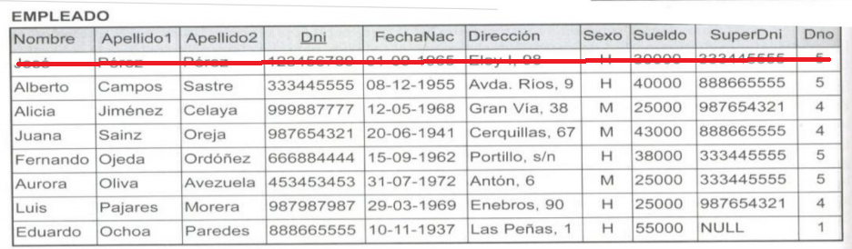
b) DELETE FROM EMPLEADO WHERE Apellido1=’Cabrera’;
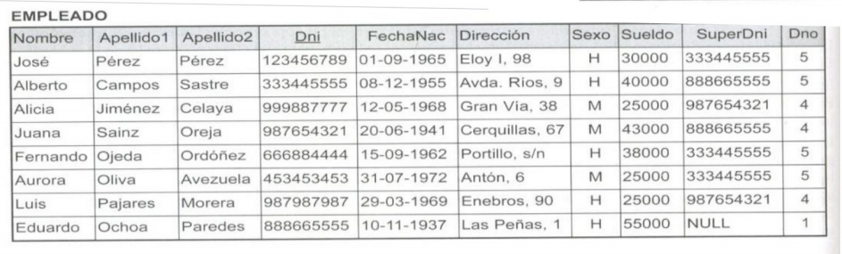
c) ALTER TABLE EMPLEADO ADD COLUMN Trabajo VARCHAR (12);
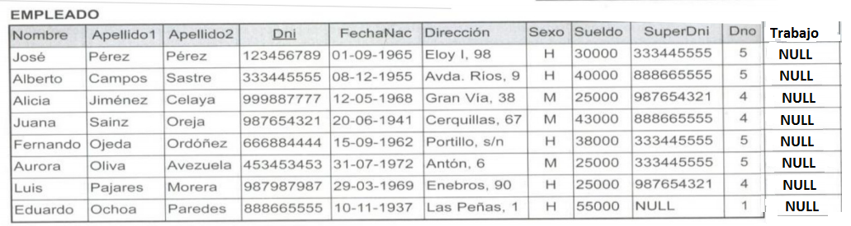
d) ALTER TABLE EMPLEADO DROP COLUMN dirección CASCADE;
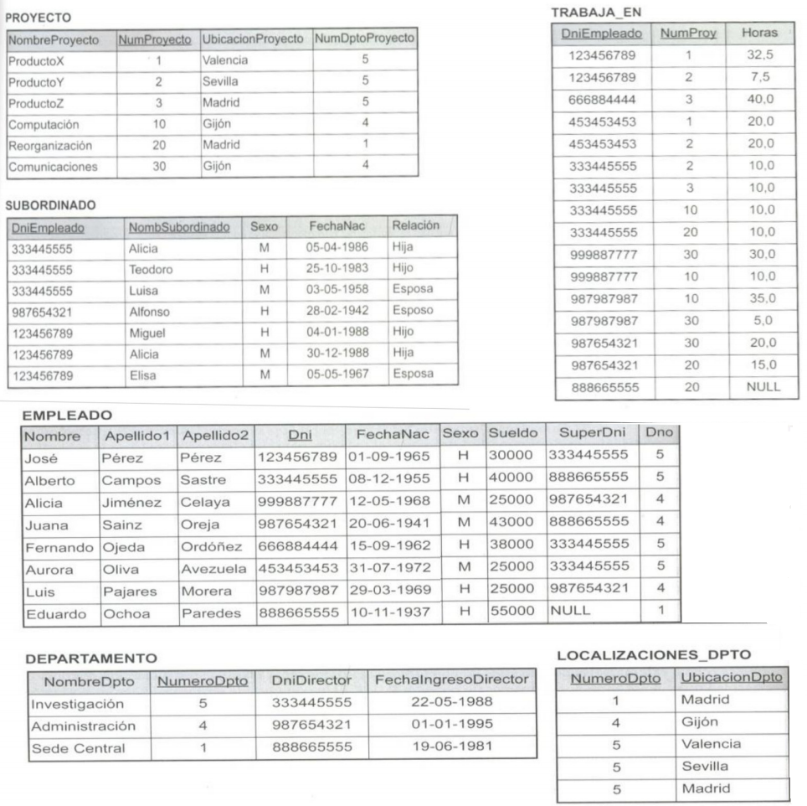
e) INSERT INTO EMPLEADO VALUES (’Ricardo’, ’Roca’, ’Flores’, ’653298653’, ’1962-12-30’, ’Los Jarales, 47’, ’H’, 37000, ’653298653’, 4);
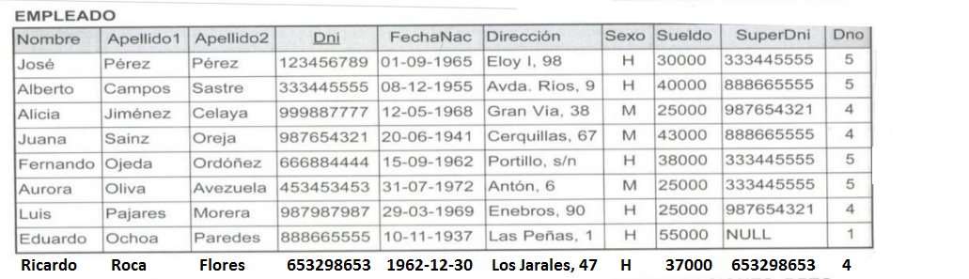

f) INSERT INTO EMPLEADO (Nombre, Apellido1, Dno, Dni) VALUES (’Ricardo’, ’Roca’, 4, ’653298653’);
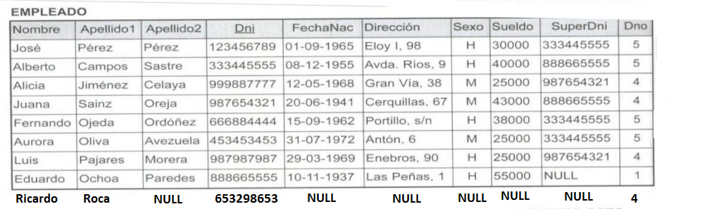

g) UPDATE PROYECTO SET UbicaciónProyecto=’Valencia’, NumDptoProyecto = 5 WHERE NumProyecto=10;
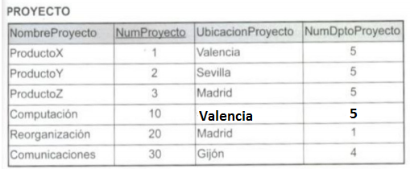

h) SELECT FechaNac, Dirección FROM EMPLEADO WHERE Nombre= 'José' AND Apellido1=’Pérez’ AND Apellido2=’Pérez’;
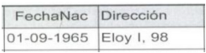

i) SELECT Nombre, Apellido1, Dirección FROM EMPLEADO, DEPARTAMENTO WHERE NombreDpto=’Investigación’ AND NumeroDpto=Dno;
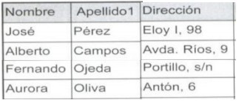

j) SELECT NumProyecto, NumDptoProyecto, Apellido1, Dirección, FechaNac FROM PROYECTO, DEPARTAMENTO, EMPLEADO WHERE NumDptoProyecto = NumeroDpto AND DniDirector=Dni AND UbicacionProyecto=’Gijon’;
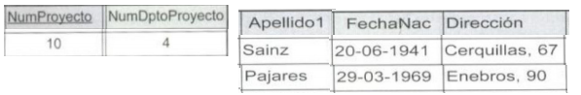

k) SELECT Nombre, Apellido1, Dirección FROM (EMPLEADO JOIN DEPARTAMENTO ON Dno=NumeroDpto) WHERE NombreDpto=’Investigación’;
